* Both your name and your teammates name

Neal Noble  
Sergio Ramirez

* What did you contribute to the current milestone?

I worked on the back end game logic. A lot time was spent on getting Bingo card functioning. It’s a type problem that more complex than it appears. A card needs consists of 5 columns with 5 rows. Each column contains random numbers within a specific range: 1-15,16-30,31-45,46-60,61-75. The problem that I had to solve was getting random numbers within each range, without duplicates to be displayed using Meteor. Keep in mind when creating the card on screen, all items are drawn in rows, not columns, so it’s not simply drawing each column of random numbers, its converting 5 columns of random numbers into 5 rows. Example:

Colum1 = [01,09,07,12,13]  
Colum2 = [18,24,27,22,16]  
Colum3 = [44,31,45,38,40]  
Colum4 = [57,60,53,56,52]  
Colum5 = [65,72,69,68,62]

Combined the 5 columns to a single array so that each column of numbers is properly aligned when assembled into 5 rows of 5 columns.

bingoCardNumbers = [01,18,44,57,65,09,24,31,60,72,07,27,45,53,69,12,22,38,56,68,13,16,40,52,62]

01-15 16-30 31-45 46-60 61-75  
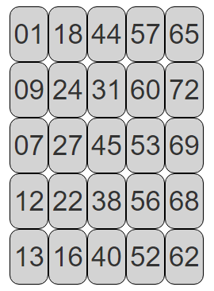

* What did your partner contribute to the current milestone?

UI design and code related to the layout

* Did you run into any roadblocks in the current milestone? If so, list them here.

A lot of the problems were related to learning the framework and simply not doing things correctly to produce the results we were expecting. Something as simple passing variables around between server, client, files, required 1-2 hours of debugging to locate the point of failure. In comparison, in Java or C#, I would have been able to solve those problems with 10-15 minutes. This is not suggesting there an inherent problem with Meteor, just that the learning curve is steep. A simple failure in the code is not easily\quickly solved at this stage primarily because the lack of familiarity with Meteor\mongo. And it’s fair to say that some implemented features will require a major over-haul later in the project because at the moment I don’t know a better way to get the job done. Have to keep pushing forward. Debugging meteor is not easy, thankfully debugging code is something I am very good at, and I have many years of experiencing isolating bugs; it is my debugging skills that have prevented the project from being blocked for too long at any one time.

* How, when and where did you meet during this milestone?

We meet 3 times at GRCC library as well as daily contact via email.